Part 1

1. Val LABEL DWORD BYTE 04H,03H,02H,01H for the value of 01020304H
2. Yes, I can but the assembler doesn’t check the number’s sign
3. ABH, 89H, 67H 45H
4. Array DWORD 120 DUP(?)
5. Array BYTE “ABCDE”
6. Val SDWORD 80000000H
7. wArray WORD 1000H, 2000H, 3000H
8. favColor BYTE “red”, 00H
9. dArray SDWORD 50 DUP(?)
10. note BYTE 500 DUP(“TEST”)
11. bArray BYTE 20 DUP(0)
12. 21H, 43H, 65H, 87H

Part 2

; Program Template (lab7p1.asm)

; Program Description: Defines symbolic constants for all of the days of the week

; Author: Timothy Bryant

; Creation Date: 2/27/2021

; Revisions:

; Date:

; Modified by:

.386

.model flat,stdcall

.stack 4096

ExitProcess PROTO, dwExitCode:DWORD

.data

; declare variables here

SUN = 0

MON = 1

TUE = 2

WED = 3

THU = 4

FRI = 5

SAT = 6

daysArray BYTE SUN, MON, TUE, WED, THU, FRI, SAT

.code

main PROC

;write your code here

INVOKE ExitProcess,0

main ENDP

; (insert additional procedures here)

END main

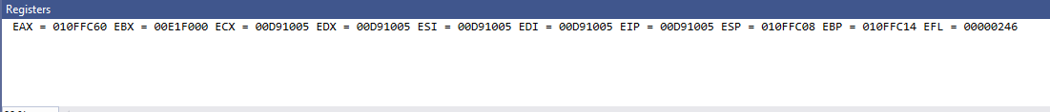

; Program Template (lab7p2.asm)

; Program Description: Definition of each data type in the table with values that consisten with its data type

; Author: Timothy Bryant

; Creation Date: 2/26/2021

; Revisions: added values to variables

; Date: 3/1/2021

; Modified by: Timothy Bryant

.386

.model flat,stdcall

.stack 4096

ExitProcess PROTO, dwExitCode:DWORD

.data

; declare variables here

val1 BYTE 12H

val2 SBYTE -12H

val3 WORD 2834H

val4 SWORD -2834H

val5 DWORD 12742834H

val6 SDWORD -12742834H

val7 FWORD 127428343456H

val8 QWORD 1274283434567891H

val9 TBYTE 1000000000123456789AH

val10 REAL4 -1.0

val11 REAL8 1.0E-260

val12 REAL10 1.0E+4000

.code

main PROC

;write your code here

INVOKE ExitProcess,0

main ENDP

; (insert additional procedures here)

END main

